int_bazaarvoice

Version 5.1.1



Summary

This document provides technical instructions for installing the Demandware Integration LINK integration that lets you integrate Bazaarvoice (BV) solutions with a Demandware storefront. This document is intended for individuals who possess at least a general understanding of the following topics:

  - Web development
  - Demandware UX Studio integrated development environment (IDE)
  - Bazaarvoice Ratings & Reviews (R&R), Ask & Answer (A&A), or Stories
  - Interface components

Component Overview

Functional Overview

The Demandware LINK integration supports the following Bazaarvoice (BV) feature set:

- Ratings & Reviews
  - Submission (including login integration)
  - Display
  - Inline Ratings on Category & Search Results pages
  - Post-Interaction Email (PIE)
  - SmartSEO Basic & SmartSEO Advanced Inline-paging
- Ask & Answer
  - Submission (including login integration)
  - Display
  - Integration at Product Page & Category Page levels
  - SmartSEO Basic & SmartSEO Advanced Inline-paging
- Stories
  - Submission (including login integration)
  - Display
  - Integration at Product Page & Category Page levels
  - SmartSEO Basic & SmartSEO Advanced Inline-paging

NOTE: As of April, 2012, Bazaarvoice deprecated support for the Active Profiles product. The Demandware LINK cartridge may contain references to support Active Profiles. These references should be ignored. No attempt should be made to implement Active Profiles using the LINK cartridge.

The Demandware LINK Integration, which is also referred to as the Bazaarvoice (BV) cartridge, provides the following integration points with Bazaarvoice (BV) solutions:

- Demandware Storefront functionality
  - Ratings & Reviews (R&R)
  - Ask & Answer (A&A)
  - Stories

- For storefront functionality to work properly, the following integration would be set up in business manager
  - Product export feed generation
  - Inline ratings feed consumption
  - Smart SEO feed consumption
  - Mobile Smart Display for R&R display and submission
  - Post-Interaction-Email (PID) feed generation

Use Cases

- Ratings & Reviews
List the use cases and appropriate action take listed below:
Use Case Scenarios | Result
The merchant implement Ratings and Reviews service from BV | User will be able to read/write ratings and reviews on product pages, and view inline ratings on category pages and search result pages.

- Ask & Answer
List the use cases and appropriate action take listed below:
Use Case Scenarios | Result
The merchant implement Ask and Answer content service from BV | User will be able to read/write Ask and Answer content on product page and category pages (optional).

- Stories
List the use cases and appropriate action take listed below:
Use Case Scenarios | Result
The merchant implement Stories service from BV | User will be able to read/write Stories content on product pages and category pages (optional).

Limitations, Constraints

Use of the Bazaarvoice Demandware LINK cartridge by itself does not grant nor enable use of the Bazaarvoice offerings (e.g. Ratings & Reviews, etc.). Bazaarvoice must separately enable the hosted Bazaarvoice SAAS services for the offerings to available on the Demandware platform. This may require a separate agreement with Bazaarvoice. Contact Bazaarvoice for details.

Compatibility

Compatible Site Genesis version 10.6

Privacy, Payment

Customer will create a display name when leaving a review. The display name will be seen to public. Bazaarvoice does not access or display any other customer profile information.
The Bazaarvoice LINK cartridge itself is available free of charge. See “Limitations, Constraints” section for details regarding potential costs involved with enabling the Bazaarvoice hosted SAAS offerings.

Implementation Guide

Prerequisites

Enabling Bazaarvoice Hosted Services
A Bazaarvoice representative must enable the hosted services for the desired
Bazaarvoice products (e.g. Ratings & Reviews, Ask & Answer, and Stories).

Bazaarvoice will complete tasks such as the following:

- Setup instance of BV hosted services
- Provide client-specific settings such as BV SFTP credentials, Hostname, Display Code, etc. to be used in the Custom Site Preferences (see section 5.1)
- Enable processes for BV to consume product catalog and order feeds generated by the LINK integration
- Enable outbound SmartSEO and Inline Ratings feeds to be consumed by the LINK integration
- Enable and configure specific features for each desired BV product
- Style the hosted visual display and submission elements

Setup

Bazaarvoice’s LINK integration uses the following cartridges:
- int_bazaarvoice – This cartridge contains all of the pipelines, templates and scripts to display and create R&R, A&A, stories and active profile. Also included pipelines to run as jobs managing feeds generates, import and export
- SiteGenesis_Sample – This cartridge contains altered templates for referencing in integration

Configuration

DNS configuration:
All implementations require the creation of the following Canonical Name (CNAME) entry for general user-generated content (UGC):

ugc.bazaarvoice.com -> [clientname].ugc.bazaarvoice.com
On a Linux server, this entry resembles the following code:

ugc IN CNAME [clientname].ugc.bazaarvoice.com; BV cache network
Additionally, you must create the following, product-specific CNAME entries where appropriate:
• For Ratings & Reviews, create the following CNAME entry:

reviews.bazaarvoice.com -> [clientname].ugc.bazaarvoice.com
• For Ask & Answer, create the following CNAME entry:

answers.bazaarvoice.com -> [clientname].ugc.bazaarvoice.com

Make sure that the domains you configure match the domains for your Demandware
storefront. This process involves setting up CNAME records for the appropriate R&R domains.

Follow the DNS setup instructions for each of the following environments:

- Sandbox
- Staging
- Production

DNS entries are necessary to satisfy the same origin policy, which typically results in the
following entries for all of the staging, development, and production boxes on your DNS
account.

- stories IN CNAME customer.ugc.bazaarvoice.com;
- answers IN CNAME customer.ugc.bazaarvoice.com;
- reviews IN CNAME customer.ugc.bazaarvoice.com;
- ugc IN CNAME customer.ugc.bazaarvoice.com ;
- Staging: staging IN CNAME staging.web. customer.demandware.net.
- Dev/Test: development IN CNAME development.web. customer.demandware.net
- Production: production IN CNAME production.web. customer.demandware.net.
- Sandbox1: sandbox1 IN CNAME sandbox1.web. customer.demandware.net.
- Sandbox2: sandbox 2 IN CNAME sandbox2.web. customer.demandware.net.
- Sandbox3: sandbox 3 IN CNAME sandbox3.web. customer.demandware.net.
- Sandbox4: sandbox 4 IN CNAME sandbox4.web. customer.demandware.net.
- Sandbox5: sandbox 5 IN CNAME sandbox5.web. customer.demandware.net.
- Sandbox6: sandbox 6 IN CNAME sandbox6.web. customer.demandware.net.

Metadata import:
- Navigate to Administration > Site Development > Site Import & Export
- Upload and import metadata_bazaarvoice.zip which includes the following:
  - System Object Definitions
    - Order:
      - bvSentInPPEFeed - Whether or not the order was already sent in Bazaarvoice PPE feed
    - Profile:
      - bvDisplayName - Username to appear in public Bazaarvoice reviews
    - Product:
      - bvAverageRating - Bazaarvoice Average Rating
      - bvRatingRange - Bazaarvoice Rating Range
      - bvReviewCount - Bazaarvoice Review Count
    - SitePreferences:
      - Bazaarvoice General - Bazaarvoice General Settings
        - bvAPIHostname - The domain from which bvapi.js is hosted. For example: [clientname].ugc.bazaarvoice.com
        - bvCustomerName - Bazaarvoice Customer Name
        - bvHostDomain - The domain from which your store will be hosted and Bazaarvoice content will be injected.
        - bvEncodingKey - Key used to encode Bazaarvoice user authentication string.
        - bvFacebookXdReceiverUrl - Facebook cross-domain channel policy file URL
        - bvFTPHost - Bazaarvoice FTP Host
        - bvFTPPassword - Bazaarvoice FTP Password
        - bvAdminEmail - The email address of the Bazaarvoice administrator. This is where feed notifications are sent.
        - bvStaging - Bazaarvoice Staging
        - bvSubmissionURL - Bazaarvoice Submission URL
        - bvSubmissionDisplayTypeJavascript - Display Type Javascript function
      - BazaarvoiceRR - Bazaarvoice R&R Settings
        - bvEnableRR - Turn on/off Bazaarvoice Ratings & Reviews.
        - bvRRDefaultDisplayCode - Bazaarvoice Ratings & Reviews Default Display Code
        - bvRRDisplayCodeJavascript - Display Code Javascript function
        - bvRRSubDomain - Bazaarvoice R&R Sub Domain
        - bvRROnEventJavascript - R&R OnEvent javascript callback
        - bvRRDisplayTypeJavascript - Display Type Javascript function
        - bvRRShowReviewsTabJavascript – Open and switch reviews tab Javascript function
      - BazaarvoiceAA - Bazaarvoice A&A Settings
        - bvEnableAA - Turn on/off Bazaarvoice Ask & Answer.
        - bvAADefaultDisplayCode - Bazaarvoice Ask & Answer Default Display Code
        - bvAADisplayCodeJavascript - Display Code Javascript function
        - bvAASubDomain - Bazaarvoice A&A Sub Domain
        - bvAAOnEventJavascript - A&A OnEvent javascript callback
        - bvQAShowQuestionsTabJavascript – Open and switch answers tab Javascript function
      - BazaarvoiceSY - Bazaarvoice Stories Settings
        - bvEnableSY - Turn on/off Bazaarvoice Stories.
        - bvSYDefaultDisplayCode - Bazaarvoice Stories Default Display Code
        - bvSYDisplayCodeJavascript - Display Code Javascript function
        - bvSYSubDomain - Bazaarvoice Stories Sub Domain
        - bvSYOnEventJavascript - Stories OnEvent javascript callback
        - bvSYDisplayFormatJavascript - Stories Display Format Javascript Function
        - bvSYSmartSEOPageFormat - Bazaarvoice Stories SmartSEO Page Format
        - bvSYShowStoriesTabJavascript - Open and switch stories tab Javascript function
      - BazaarvoiceCP - Bazaarvoice Active Profiles Settings (Deprecated)
        - bvCPDefaultDisplayCode - Bazaarvoice Active Profiles Default Display Code
        - bvCPDisplayCodeJavascript - Display Code Javascript function
        - bvCPSubDomain - Bazaarvoice Active Profiles Sub Domain
        - bvCPOnEventJavascript - Active Profiles OnEvent javascript callback
        - bvCPRenderEditProfileLink - Render Edit Profile Link
      - BazaarvoiceProductFeed - Bazaarvoice Product Feed Export Settings
        - bvEnableProductFeed - Turn on/off Product Feed generation.
        - bvProductFeedExportPath - Bazaarvoice FTP Export File Path
        - bvProductFeedExportFileName - Bazaarvoice Product Feed Export File Name
      - BazaarvoiceInlineRating - Bazaarvoice Inline Rating Settings
        - bvEnableInlineRatings - Turn on/off Inline Ratings
        - bvInlineRatingsFeedPath - Bazaarvoice Inline Rating Feed Path
        - bvInlineRatingsFeedFileName - Bazaarvoice Inline Rating Feed Filename
      - BazaarvoiceSmartSEO - Bazaarvoice Smart SEO Settings
        - bvEnableSmartSEO - Turn on/off Smart SEO
        - bvSmartSEOFeedPath - Bazaarvoice Smart SEO Feed Path
        - bvSmartSEOFeedFileName - Bazaarvoice Smart SEO Feed Filename
        - bvSmartSEOMaxStaleDays - Bazaarvoice Smart SEO Maximum Content Staleness
      - BazaarvoicePurchaseFeed - Bazaarvoice Purchase Feed Settings
        - bvEnablePurchaseFeed - Turn on/off Purchase Feed generation.
        - bvPurchaseFeedPath - FTP Upload Path
        - bvPurchaseFeedFileName - FTP Upload Filename
        - bvPurchaseFeedTriggeringEvent - whether to use the purchase date or ship date when calculating which purchases to include
        - bvPurchaseFeedDelayDaysSinceEvent - the number of days to wait after the triggering event
        - bvPurchaseFeedNumDaysLookback - number of days of historical transactions

Assign the cartridge to your site:
- Navigate to Administration > Sites > Manage Sites > [SiteName] > Settings Tab
- Add “:int_bazaarvoice” to the effective cartridge path and click “Apply”.

Turn on feeds import and export:
- Navigate to Site > [your site] > Site Preferences
  - > BazaarvoiceProductFeed
    - Turn on “Bazaarvoice Product Feed” and configure preferences
  - > BazaarvoicePurchaseFeed
    - Turn on “Enable Purchase Feed” and configure preferences
  - > BazaarvoiceInlineRating
    - Turn on “Bazaarvoice Inline Rating” and configure preferences
  - > BazaarvoiceSmartSEO
    - Turn on “Bazaarvoice Smart SEO” and configure preferences

Create and configure jobs:
- Navigate to Administration > Operations > Job Schedules and create the following new jobs
  - ExportProductFeed
    - Description: This job should run once a day to generate and export any category and product on the site to Bazaarvoice. The job also send out the feed status notification on finish, success and fail
    - General >
      - Name: ExportProductCatalog
      - Execution Scope: Sites
      - Pipeline: BazaarvoiceData
      - StartNode: ExportProductCatalog
      - Recurring Interval: (daily - set to coordinate with BV schedule for consuming the product catalog feed)
    - Sites >
      - Select [YourSite]
    - Notification >
      - Select Enabled
      - Threshold, select Exception, Error, Hang
  - Export Purchase Data
    - Description: This job should run once a day to generate and export any order within the trigger event date range on the site to Bazaarvoice. The job also send out the feed status notification on finish, success and fail
    - General >
      - Name: ExportPurchaseData
      - Execution Scope: Sites
      - Pipeline: BazaarvoiceData
      - StartNode: ExportPurchaseData
      - Recurring Interval: (daily - set to coordinate with BV schedule for consuming the order/purchase data feed)
    - Sites >
      - Select [YourSite]
    - Notification >
      - Select Enabled
      - Threshold, select Exception, Error, Hang

  - Import Inline Rating Feed
    - Description: This job should run once a day to import the inline rating feed from Bazaarvoice to the site. The job also send out the feed status notification on finish, success and fail
    - General >
      - Name: ImportInlineRatingsFeed
      - Execution Scope: Sites
      - Pipeline: BazaarvoiceData
      - StartNode: ImportRatingFeed
      - Recurring Interval: (daily - set to coordinate with BV schedule for generating the XML ratings feed)
    - Sites >
      - Select [YourSite]
    - Notification >
      - Select Enabled
      - Threshold, select Exception, Error, Hang
  - Import Smart SEO Feed
    - Description: This job should be a nightly job once a day to import the SmartSEO feed from Bazaarvoice to the site. The job also send out the feed status notification on finish, success and fail
    - Pipeline: BazaarvoiceData
    - StartNode: ImportSmartSEO
    - General >
      - Name: ImportSmartSEOFeed
      - Execution Scope: Sites
      - Pipeline: BazaarvoiceData
      - StartNode: ImportSmartSEO
      - Recurring Interval: (daily - set to coordinate with BV schedule for generating SmartSEO feed)
    - Sites >
      - Select [YourSite]
    - Notification >
      - Select Enabled
      - Threshold, select Exception, Error, Hang

Configure Customer Site Preferences:
- Navigate to Site > Site Preferences > Custom Preferences
- Configure the Custom Site Preferences for:
  - Bazaarvoice General Settings
  - Bazaarvoice R&R Settings (if applicable)
  - Bazaarvoice A&A Settings (if applicable)
  - Bazaarvoice Stories Settings (if applicable)
- See Section 5.1 for sample settings for each set of preferences

Custom Code

The included sample cartridge, “SiteGenesis_Sample”, includes any changes that would need to be made assuming you are using the Site Genesis reference storefront.

Templates
- pt_productdetail.isml
- product.isml
- productsearchhittile.isml
- pt_productsearchresult.isml
Resource
- product.properties

Ratings & Reviews:

To integrate the R&R display templates, add the following <isinclude> elements to the various templates that comprise the product information page:

- <isinclude template="bv/display/headerincludes"/>

Place this <isinclude> element in the product ISML template file that contains your
HTML head. If your store is based on SiteGenesis, add this element to
pt_productdetail.isml immediately before the close of the head tag.

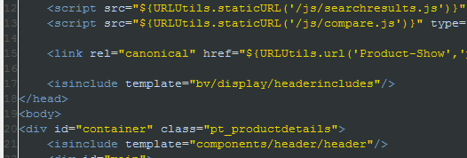
- <isinclude template="bv/display/rr/reviewsummary"/>

Place this <isinclude> element in the product information ISML template in which you want to display the average rating information. If your store is based on SiteGenesis, add this element to product.isml, replacing the existing include for product/components/reviewsmini.
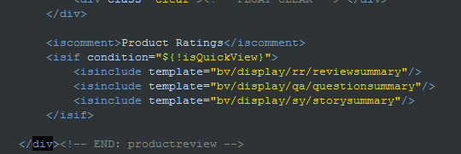
- <isinclude template="bv/display/rr/reviews"/>

Place this <isinclude> element in the product information ISML template in which you want to display the actual reviews. If your store is based on SiteGenesis, add this element to product.isml, replacing the existing include for product/components/reviews.
The <div> tag id needs to match with the link location on tab.

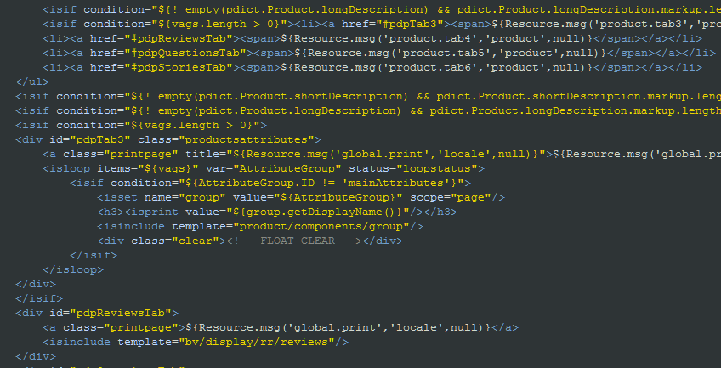

- <isinclude template="bv/display/rr/inlineratings"/>

Place this <isinclude> element in any pages in which you want only an overall star rating image to appear next to a product, such as a search page or a category page that lists your products. If your store is based on SiteGenesis, add this element to productsearchhittile.isml so that it appears immediately beneath the product image and title on your category pages and search results pages.
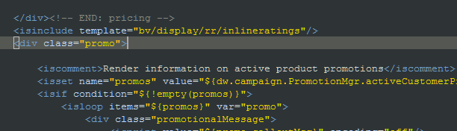

Note: If your site is based on SiteGenesis, remove the <div> container that contains the class reviewlinks.

- Include the following javascript to site preference, “Show Reviews Tab Javascript function”.
  - Navigate to Site > [YourSite ] > Site Preferences > BazaarvoiceRR
  - Add the following code to “Show Reviews Tab Javascript”

jQuery('#pdpTabsDiv').tabs('select', 'pdpReviewsTab');

Ask & Answer:

To integrate the A&A display templates, add the following <isinclude> elements to the various templates that comprise the product or category information pages:

- <isinclude template="bv/display/headerincludes"/>

Place this <isinclude> element in the product or category ISML template file that contains your HTML head. If your store is based on SiteGenesis, add this element to pt_productdetail.isml, to pt_productsearchresult.isml, or to both files immediately before the close of the head tag.
  - pt_productdetail.isml
  - pt_productsearchresult.isml
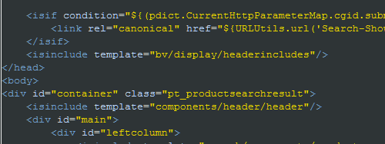
- <isinclude template="bv/display/qa/questionsummary"/>

Place this <isinclude> element in the product or category information ISML template in which you want to display such question-summary information as the total number of questions. If your store is based on SiteGenesis, add this element to product.isml, to pt_productsearchresult.isml, or to both files.

  - product.isml

  - pt_productsearchresult.isml
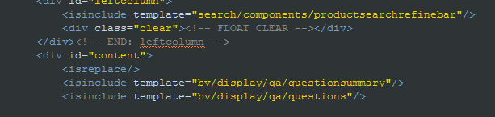
- <isinclude template="bv/display/qa/questions"/>

Place this <isinclude> element in the product or category information ISML template in which you want to display the actual questions. If your store is based on SiteGenesis, add this element to product.isml, to pt_productsearchresult.isml, or to both files.

  - pt_productsearchresult.isml

  - To add a questions tab on product page, and if your store is based on SiteGenesis, please include the following code on product page, product.isml. The <div> tag id needs to match with the link location on tab.
    - Include the following line in pdpTabsDiv as a list item
<li><a href="#pdpQuestionsTab"><span>${Resource.msg('product.tab5','product',null)}</span></a></li>
    - Include the following code after phpReviewsTab
<div id="pdpQuestionsTab">
<a class="printpage">${Resource.msg('global.print','locale',null)}</a>
<isinclude template="bv/display/qa/questions"/>
</div>

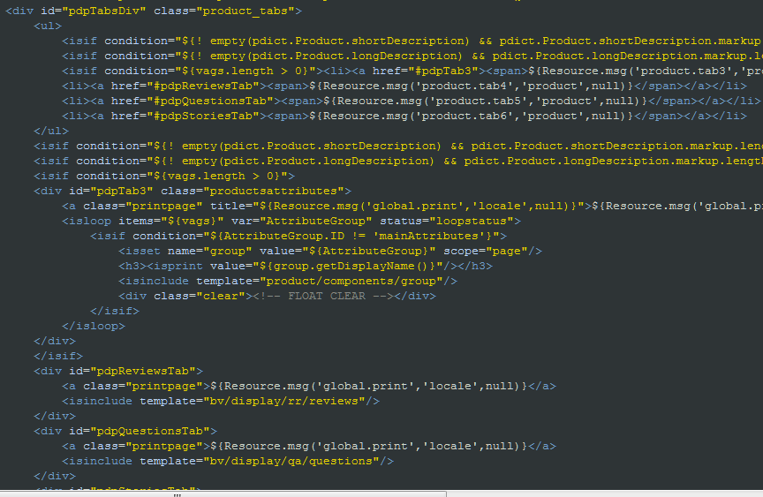
- Add tab display labels in the resource file, product.properties
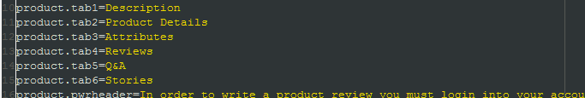
- Include the following javascript to site preference, “Show Q&A Tab Javascript function”.
  - Navigate to Site > [YourSite ] > Site Preferences > BazaarvoiceAA
  - Add the following code to “Show Q&A Tab Javascript”

jQuery('#pdpTabsDiv').tabs('select', 'pdpQuestionsTab');

Stories:

To integrate the Stories display templates, add the following <isinclude> elements to the
various templates that comprise the product or category information pages:

- <isinclude template="bv/display/headerincludes"/>

Place this <isinclude> element in the product or category ISML template file that contains your HTML head. If your store is based on SiteGenesis, add this element to pt_productdetail.isml, to pt_productsearchresult.isml, or to both files immediately before the close of the head tag.

  - pt_productdetail.isml
  - pt_productsearchresult.isml
- <isinclude template="bv/display/sy/storysummary"/>

Place this <isinclude> element in the product or category information ISML template in
which you want to display such story summary information as the total number of stories. If your store is based on SiteGenesis, add this element to product.isml, to pt_productsearchresult.isml, or to both files.

  - product.isml
  - pt_productsearchresult.isml

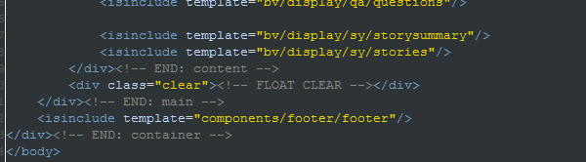
- <isinclude template="bv/display/sy/stories"/>

Place this <isinclude> element in the product or category information ISML template in which you want to display the actual stories. If your store is based on SiteGenesis, add this element to product.isml, to pt_productsearchresult.isml, or to both files.

  - pt_productsearchresult.isml
  - To add a stories tab on product page, and if your store is based on SiteGenesis, please include the following code on product page, product.isml. The <div> tag id needs to match with the link location on tab.
    - Include the following line in pdpTabsDiv as a list item
<li><a href="#pdpStoriesTab"><span>${Resource.msg('product.tab6','product',null)}</span></a></li>
    - Include the following code after pdpQuestionsTab
<div id="pdpStoriesTab">
<a class="printpage">${Resource.msg('global.print','locale',null)}</a>
<isinclude template="bv/display/sy/stories"/>
</div>
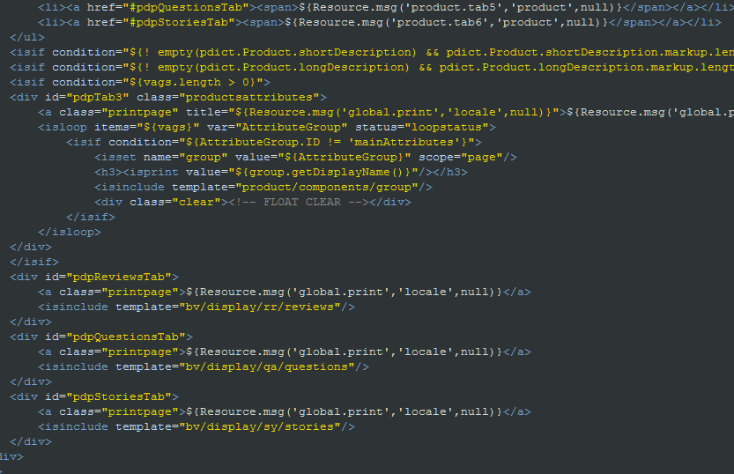
- Add tab display labels in the resource file, product.properties

- Include the following javascript to site preference, “Show Stories Tab Javascript function”.
  - Navigate to Site > [YourSite ] > Site Preferences > BazaarvoiceSY
  - Add the following code to “Show Stories Tab Javascript”

jQuery('#pdpTabsDiv').tabs('select', 'pdpStoriesTab');

Custom Star Images:
User can replace the star images to custom ones or customize the look and feel of inline rating reviews in this plug-in. The images are located in int_bazaarvoice/static/default/images/stars. User can replace the existing ones to the custom ones with the same naming. Contact Bazaarvoice for a copy of the star images used in the BV-hosted display.
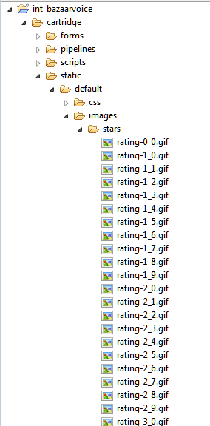

External Interfaces

A subdomain that is used for all user-facing URLs – including submission URLs, deep-linking URLs, and links to landing pages – must point to Bazaarvoice servers. All implementations requires are in 3.2 DNS Configuration.

Testing

To view an un-styled demonstration of Bazaarvoice R&R, A&A, and Stories integrated with the Demandware Site Genesis Storefront, visit the following site:

http://bazaarvoice01.tech-prtnr-na01.dw.demandware.net/on/demandware.store/Sites-SiteGenesis-Site

Operations, Maintenance

Data Storage

The export and import feeds will be stored under webdav/Sites/Temp while the jobs are running and deleted when the jobs finished. There will not be feeds storage on Impex.

Availability

BV hosted services perform with an uptime of 99.9% reliability. Additionally, the Bazaarvoice services are designed in such a way to gracefully fail without impact on the Demandware webstore performance. If the event of failure, Bazaarvoice functionality will simply cease to exist on the target pages.

Support

Contact partner-support@bazaarvoice.com regarding this LINK cartridge.

User Guide

Roles, Responsibilities

Recursive jobs should be scheduled to run in daily basis. Before running each job, make sure the feeds are turned on in site preferences group.

- Product Feed Export
- PurchaseData Feed Export
- Inline Rating Feed Import
- SmartSEO Feed Import

Business Manager

Bazaarvoice Custom Site Preference Groups for Bazaarvoice consist of the following:
Site > Site Preferences > Custom Preferences

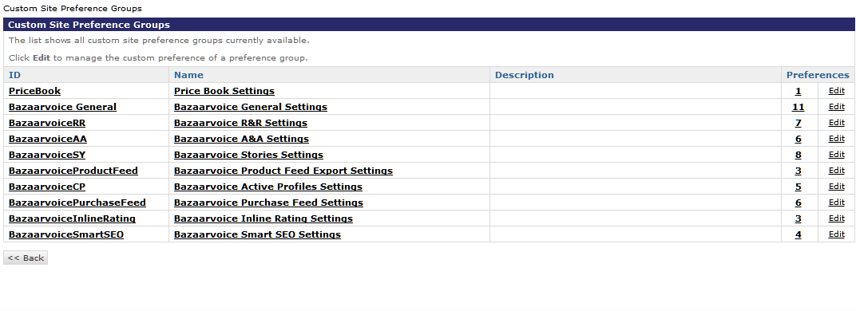
Image: Custom Site Preference Groups

- Bazaarvoice General
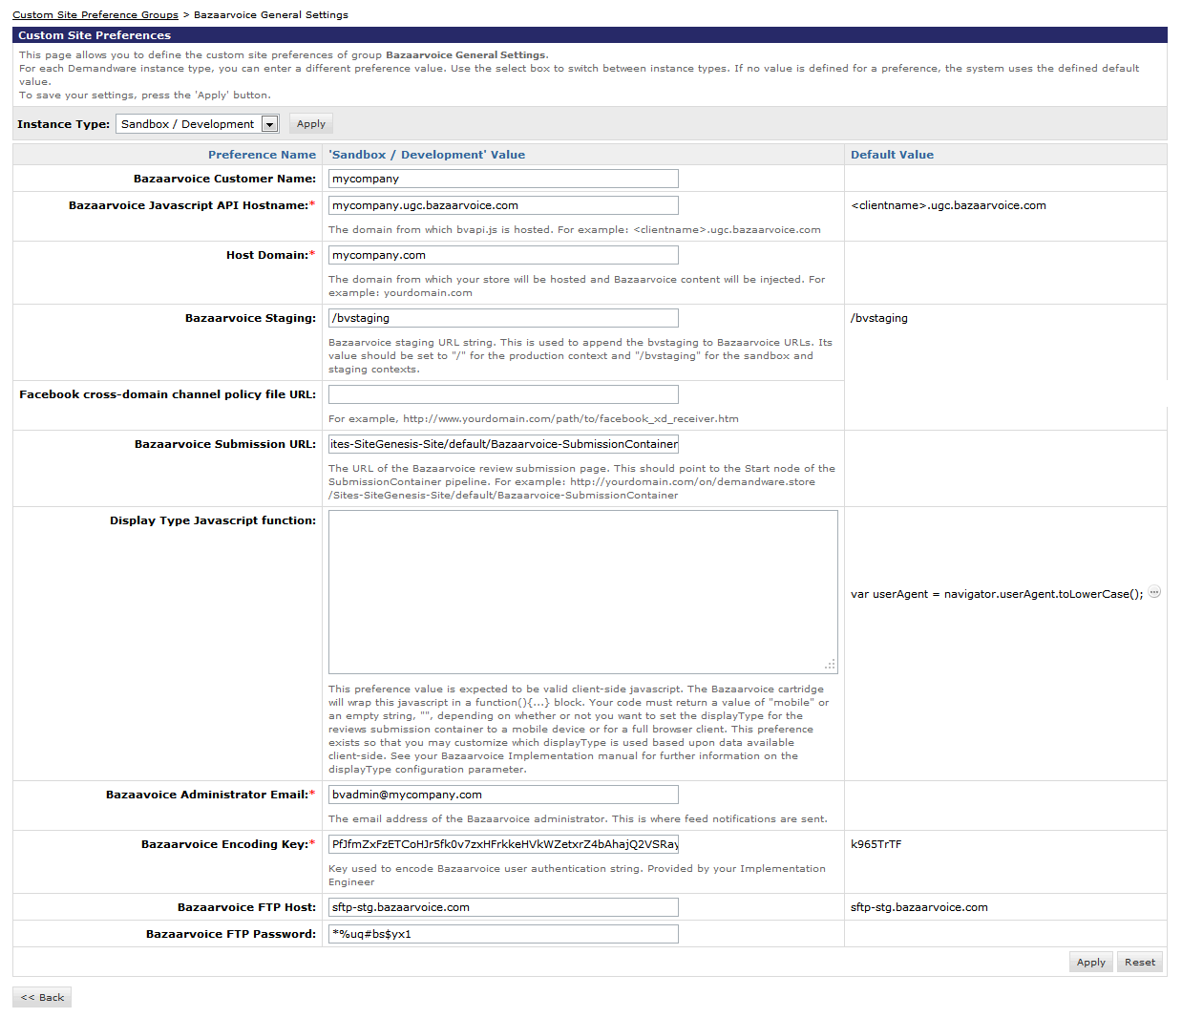Image: Bazaarvoice General Settings
- BazaarvoiceRR
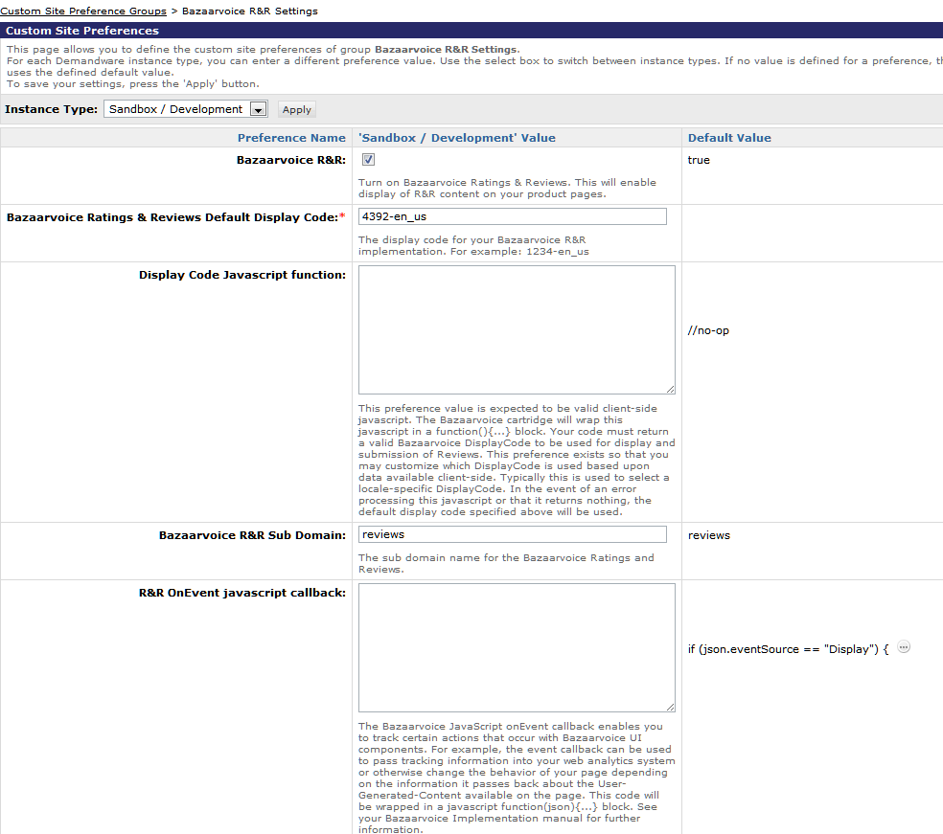
Image: Bazaarvoice Rating & Reviews Settings
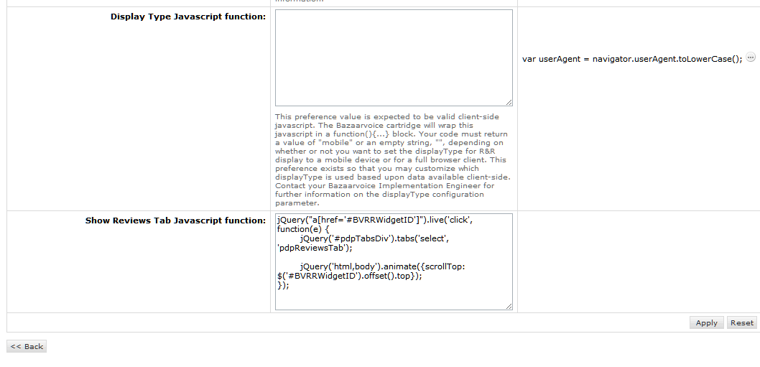
Image: Bazaarvoice Rating & Reviews Settings (cont.)
- BazaarvoiceAA
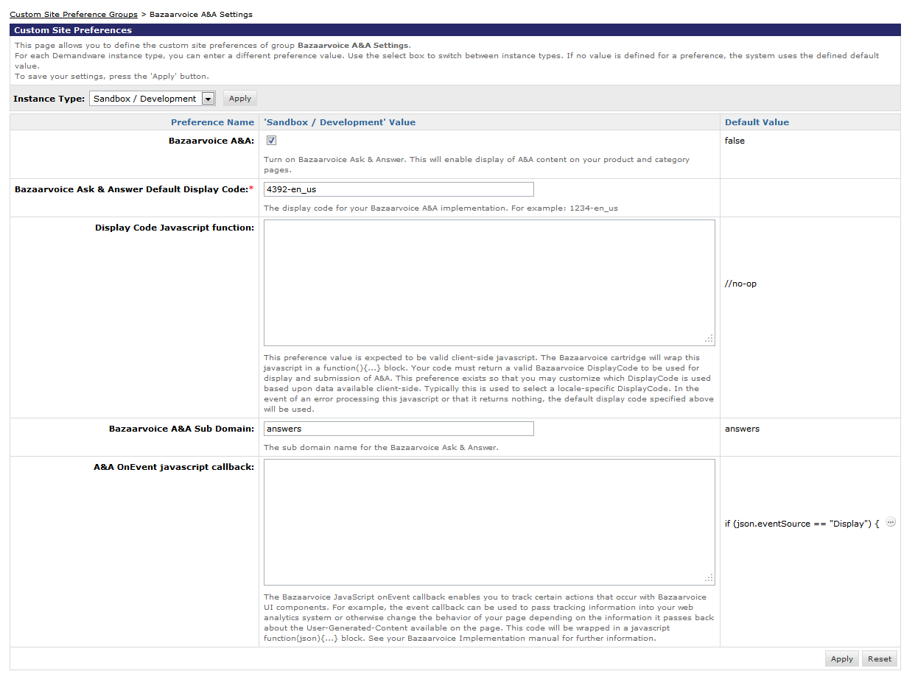
Image: Bazaarvoice Ask & Answer Settings
- BazaarvoiceSY
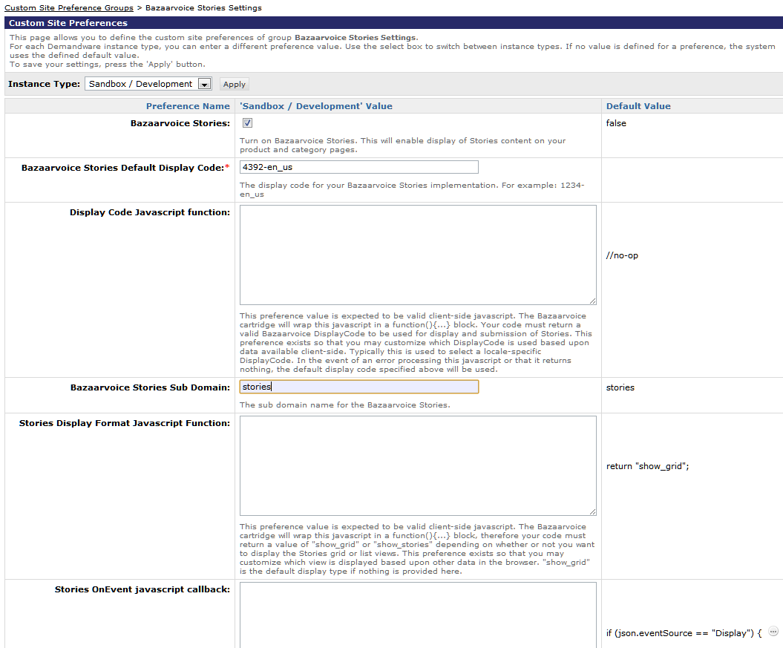
Image: Bazaarvoice Stories Settings
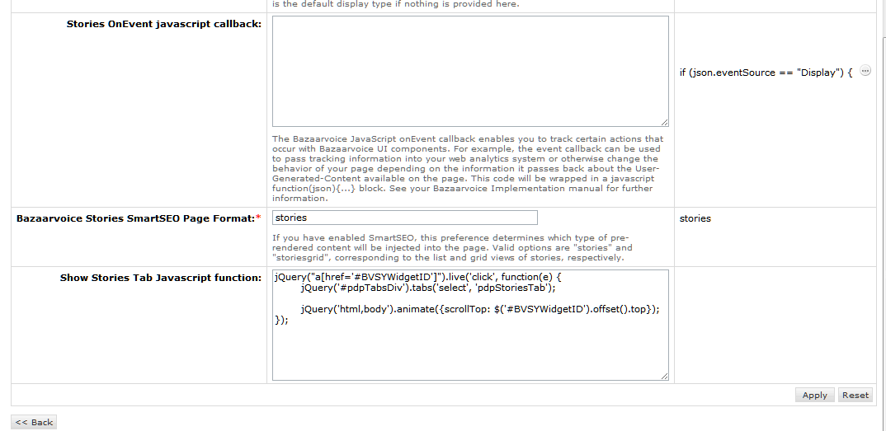
Image: Bazaarvoice Stories Settings (cont.)
- BazaarvoiceProductFeed
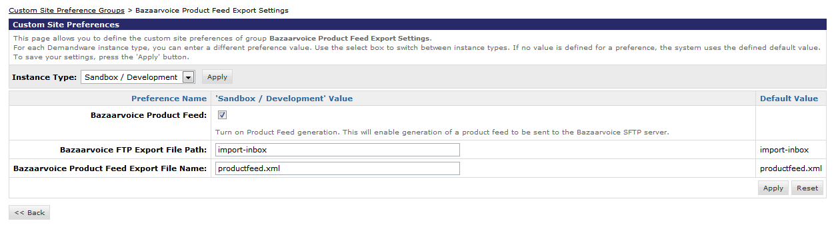
Image: Bazaarvoice Product Feed Export Settings
- BazaarvoiceCP (NOTE: These preferences are for the “Active Profiles” feature/product. This feature has been deprecated by Bazaarvoice. Do not use these preferences.)
- BazaarvoicePurchaseFeed
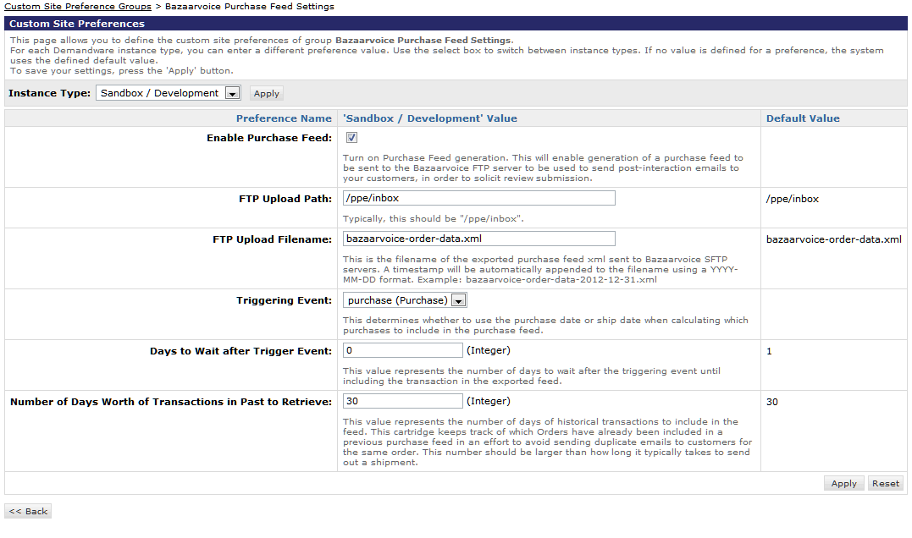
Image: Bazaarvoice Purchase Feed settings
- BazaarvoiceInlineRating
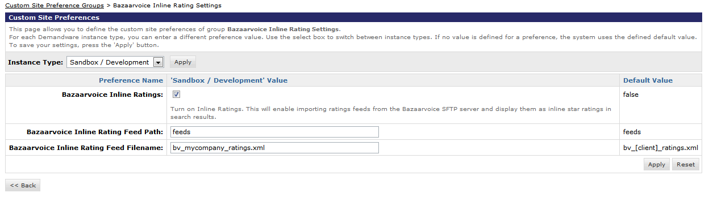
Image: Bazaarvoice Inline Ratings Settings
- BazaarvoiceSmartSEO
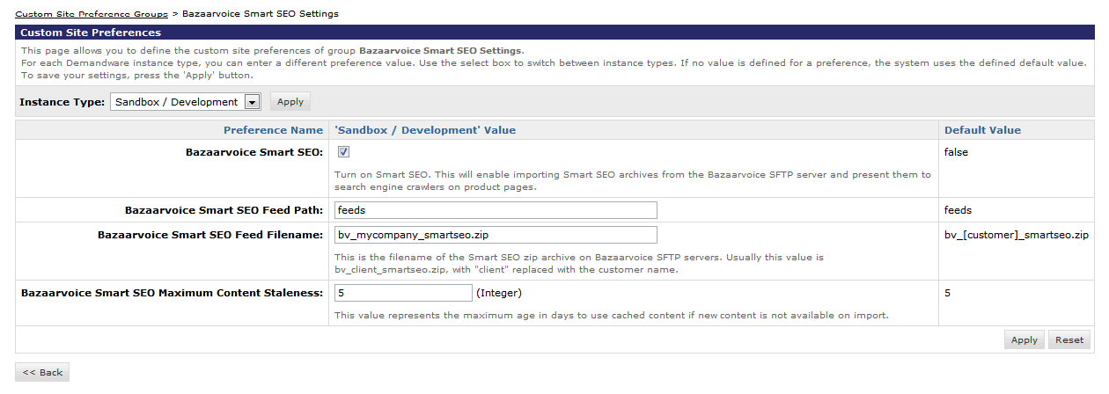
Image: Bazaarvoice SmartSEO settings

Storefront Functionality

Inline Ratings (Category, Search Results pages):

When using the inline rating for search result and/or category pages, after the importInlinerating feed success, you should be able to see the appropriate star rating image, average rating statistic, and rating count statistic for each product displayed on the search result and/or category page.

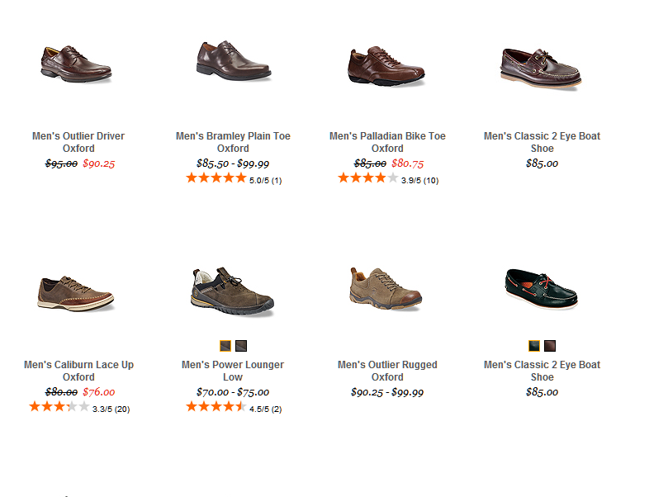
Product Page:

When the product page template has been updated to include the Bazaarvoice DIV tags, you should be able to see the ratings and reviews, ask and answers (if applicable), and stories (if applicable) on the product page.

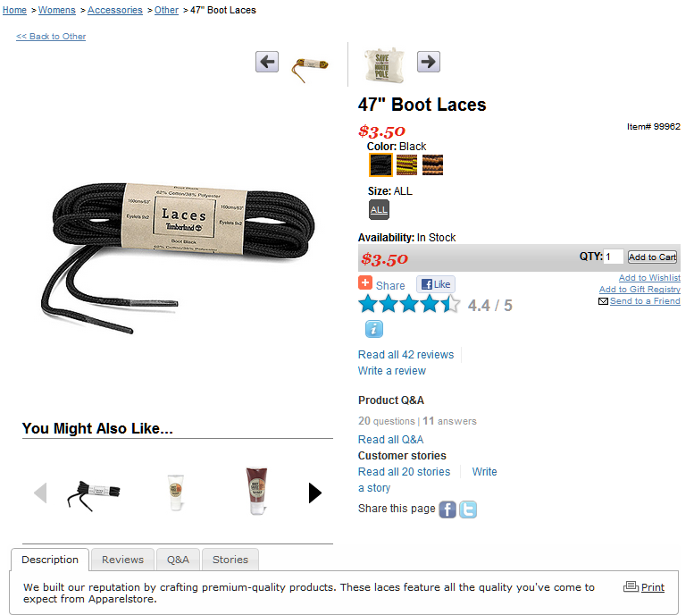

The “Write a review link” will take you to the submission link that you defined in site preference.

All of the templates that handle the display of Bazaarvoice data reside in the
default/bv/display subdirectory of the templates directory. All of the templates that handle
the submission of Bazaarvoice data reside in the default/bv/submit subdirectory of the
templates directory.

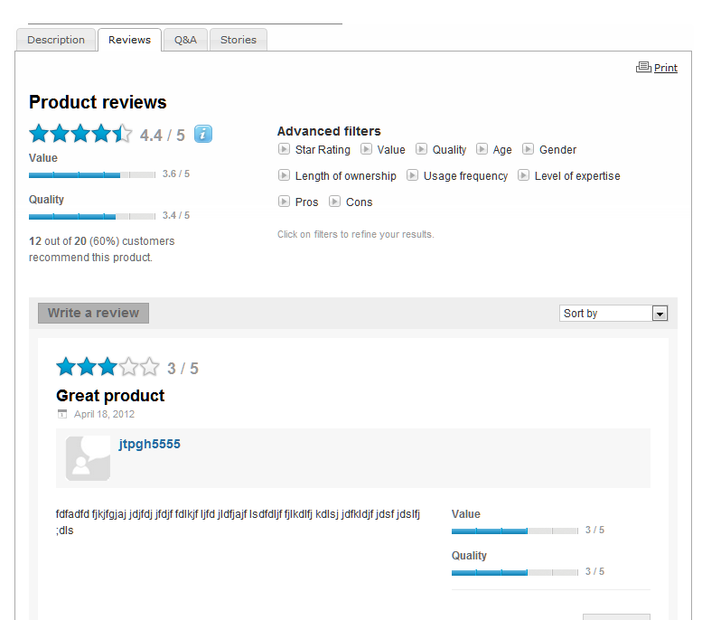
Submission Container Integration Templates

The Bazaarvoice products R&R, A&A, and Stories share the same submission container. All submission templates are referenced from within the Bazaarvoice templates, so you do not need to include them elsewhere in the storefront. The file submissioncontainer.isml renders the page that contains the submission form.

All of the logic that handles user authentication and that redirects the user to and from the login page is handled within the Bazaarvoice pipeline. The following URL provides an example of a URL that points toward the generic submission container.

.../on/demandware.store/Sites-SiteGenesis-Site/default/Bazaarvoice- SubmissionContainer

Known Issues

Release History

Version | Date | Changes
5.1.1 |  | - Quota violation fix for plugin version 5.1  - Included functionality to open tab on PDP when clicking “read all reviews” (analogous fixes for displaying Ask & Answer and Stories content behind tabs)  - Removed default value for “Bazaarvoice Encoding Key” preference  - Removed global preference for bvdisplaycode (no longer used)  - Timestamp automatically appended to Order Feed XML filename  - Ratings statistics set to zero for all products prior to new statistic values being imported from XML ratings feed

? int_bazaarvoice, version 5.1.1

